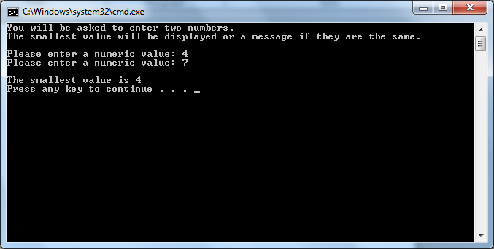

// ---------------------------------------------------------------

// Developer: Kevin Nguyen

// Date Written: May 15, 2015

// Purpose: Determine Smallest Number

// ---------------------------------------------------------------

#include<iostream>

usingnamespace std;

void main()

{

int A, B;

cout <<"You will be asked to enter two numbers.\nThe smallest value will be displayed or a message if they are the same.\n";

cout << endl;

cout <<"Please enter a numeric value: ";

cin >> A;

cout <<"Please enter a numeric value: ";

cin >> B;

cout << endl;

if (A>B){

cout <<"The smallest value is "<< B;}

elseif

(A<B){

cout <<"The smallest value is "<< A;}

else cout <<"Both values are equal.";

cout << endl;

system("pause");

}